**The remittance industry has been an integral part of Singapore’s Financial Sector for decades**

Remittance services provide an individual or a business with the means to transfer funds to a recipient with or without a bank account. These transactions typically have been over the counter using cash but digital platforms are fast becoming a popular method.

Remittance businesses have fast grown and with the adoption of financial technology offer the same or even better services and range of products than banks. As seen lately, startup fintechs have used technology to innovate international payment methods which can be more convenient.

Always use a licensed remittance agent. Find out using the

**Financial Directory of the MAS.**

**Much faster, cheaper and with a sophisticated network remittance businesses serve the interests of locals and foreigners in Singapore. Flat fees & competitive exchange rates also give preference of using a remittance service over a bank.**

With the introduction of Payments Services Act, much focus have been given to the security of consumers funds. Such enforcements have indeed raised the standards in protecting funds till it reaches its destination. Overall, technology has indeed favoured the traditional industry to compete with the big banks and give a run for their money.



FOREIGN WORKERS

**Foreign Workers are the foundation of**

**Singapore’s labour force.**

A good proportion of Singapore’s labour force work in the construction industry. The sector contains large number of workers mainly from India, Bangladesh, Thailand, Myanmar & China. These are skilled workers in construction and usually stay in dormitories. With a good proportion of their wages needed to be sent home back to their loved ones, they are the target of many remittance businesses. A number of remittance agents operate out of these dorms particularly where there is a large population of workers making it easy for them transfer money without having to leave to elsewhere. There are also remittance kiosks and mobile & web applications developed specially for their use.

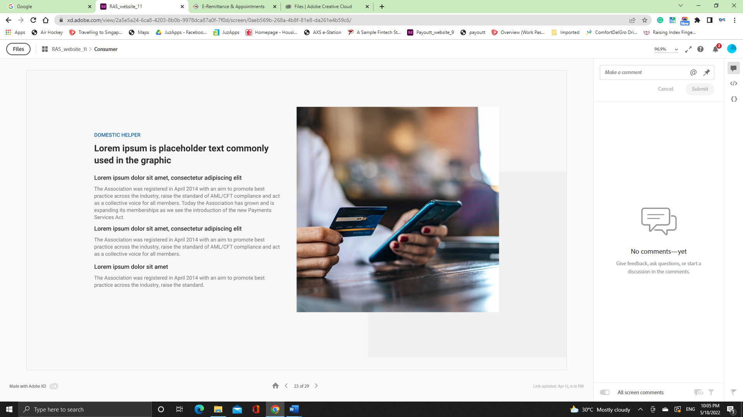

DOMESTIC HELPERS

Singapore families employ domestic helpers to assist them with their household chores. There are large sizable community of domestic helpers from Indonesia, Philippines, Myanmar and India. There are approximately on average 240,000 domestic workers in Singapore. Domestic helpers usually are breadwinners for their families back in their country. Usually many of these helpers send a large proportion of their salary back home. Looking for cheap or no fees and competitive exchange rates, they flock to remittance agents at popular malls such as City Plaza, Lucky Plaza & Peninsula Plaza.

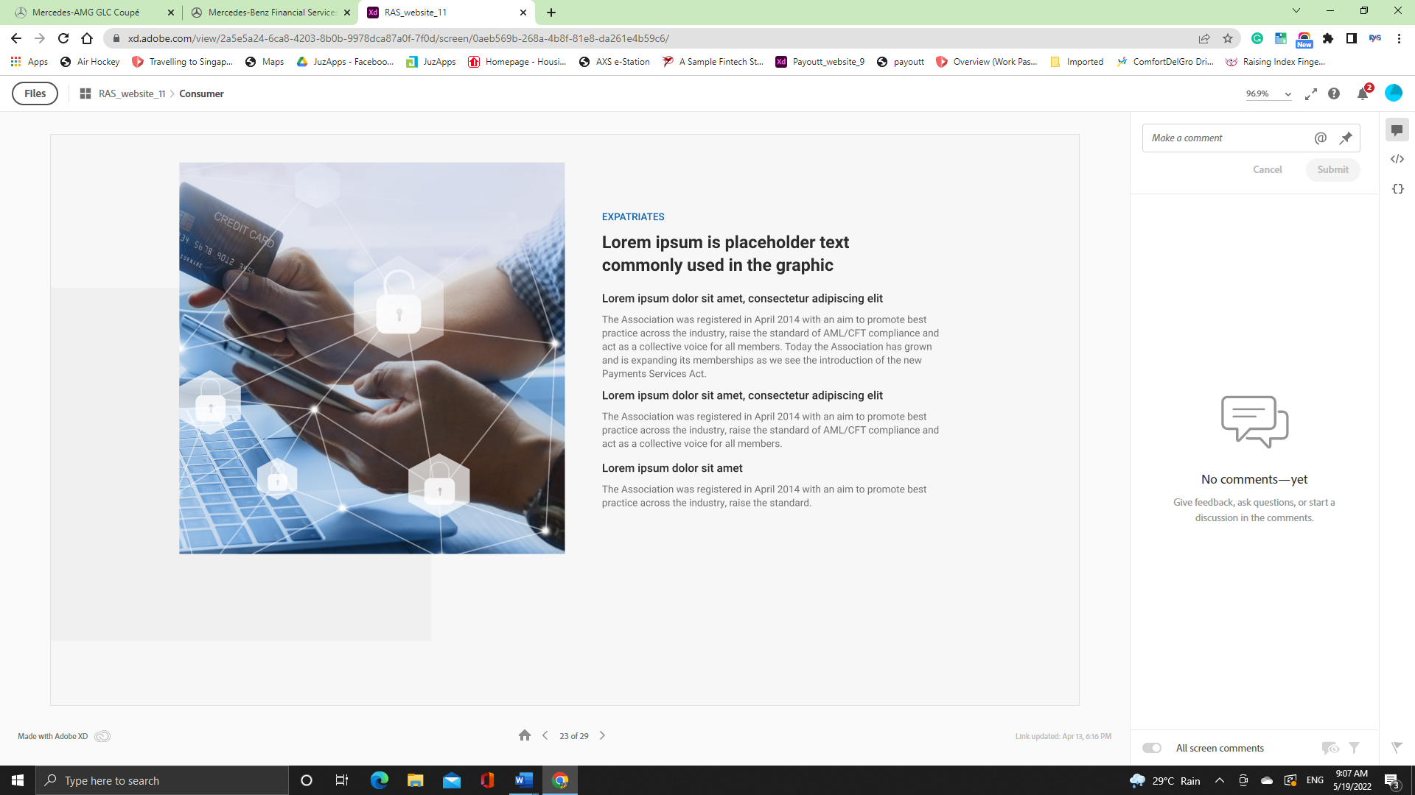

EXPATRIATES

Being a global business and financial centre, Singapore often attracts talents to live and work here. With over 100,000 expats, they take the managerial positions in corporates and other MNCs based here. With family and other personal commitments, these expats have to remit money home. As the amount for remittance can be large and regular, expats tend to use the banks or the larger and well known remittance companies. Nowadays many are attracted to the convenience of electronic remittance.

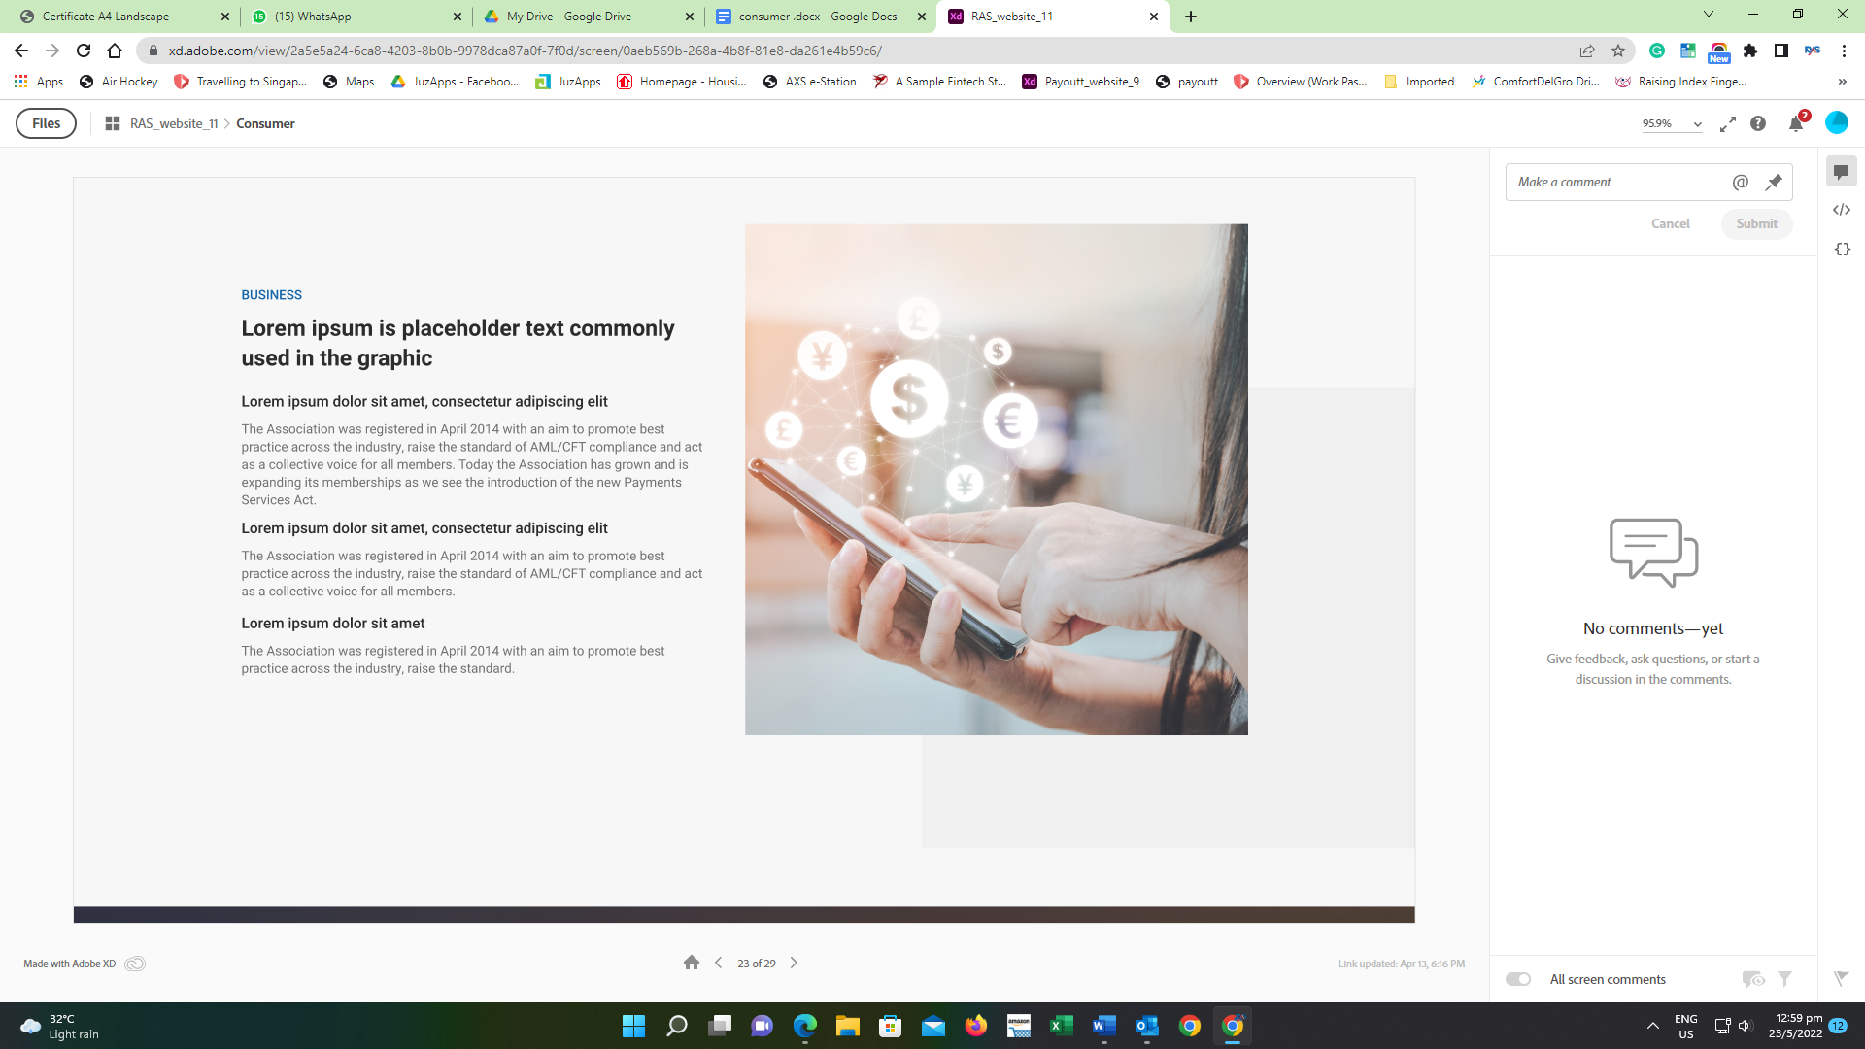

Many local SMEs tend to save on operational and administrative costs. That is why we see many such businesses using remittance services provided by money transfer companies. A bulk of these are payments are actually payments for overseas suppliers who usually provide these firms with goods or services. Some of these companies also use remittance services for incoming payments usually from their buyers. When using remittance companies, local businesses usually cut alot of costs by getting competitive Fx rates & minimum or zero charges.

**Scams**

With the rise in SCAMS, consumers are advised to be cautious of such cheating. Remittance houses have been witnessing many customers sending money to be involved in SCAMS. The Remittance Association also has helped to join in the fight against SCAMS and educates members and consumers on the awareness of such schemes. As part of our fight, we have organised webinars on SCAM AWARENESS for members and designed posters to educate consumers of money transfer services.

The Police would like to advise members of the public to take precautions when they receive calls from unknown parties:

* Ignore the calls. Scammers may use Caller ID spoofing technology to mask the actual phone number and display a different number.  Calls that appear to be from a local number may not actually be made from Singapore. If you receive a suspicious call from a local number, hang up, wait five minutes, then call the number back to check the validity of the request.
* Ignore instruction to remit or transfer money. No government agency will inform you to make a payment through a telephone call, especially to a third party's bank account.
* Refrain from giving out personal information and bank details, whether on the website or to callers over the phone. Personal information and bank details such as internet bank account usernames and passwords, OTP codes from tokens, are useful to criminals.
* Call a trusted friend or talk to a relative before you act. You may be overwhelmed by emotion and make errors in your judgment.
* If you have information related to such crime or if you are in doubt, please call the Police hotline at 1800-255-0000, or dial 999 for urgent Police assistance.